From Data to Insight: A Comprehensive Data Science Exploration Report

Introduction

Based on the provided dataset, here is an overall general introduction:  
  
The dataset provides information on 29 patients' blood glucose levels (BG) and continuous glucose monitor (CGM) readings over a period of 8 hours, from 6:00 AM to 8:00 PM, on October 25, 2023. The patients' ages range from adolescence to adulthood, with the youngest patient being 14 years old and the oldest patient being 65 years old.  
  
The dataset shows a wide range of blood glucose levels, with some patients experiencing high blood glucose levels (greater than 180 mg/dL) and others experiencing low blood glucose levels (less than 70 mg/dL). The CGM readings indicate that the patients' blood glucose levels fluctuate throughout the day, with some patients experiencing sharp increases or decreases in blood glucose levels.  
  
The dataset also provides information on the patients' risk levels, with some patients classified as high risk and others as low risk. The risk levels are determined based on the patients' medical history, lifestyle, and other factors.  
  
Overall, the dataset provides valuable insights into the complex interplay between blood glucose levels and various factors that can affect them,

Summary Statistics

Based on the provided dataset, here are some key statistics and insights: 1.  
Count: The dataset  
contains 31680 observations.  
2.  
Mean: The mean of BG, CGM, CHO, and insulin is 113.15, 116.4, 0.13,  
and 0.03, respectively.  
3.  
Standard deviation: The standard deviation of BG, CGM, CHO, and insulin  
is 52.7, 52.6, 1.3, and 0.15, respectively.  
4.  
Minimum: The minimum value of BG, CGM, CHO, and  
insulin is 6.6, 39, 0, and 0.0065, respectively.  
5.  
25th percentile: The 25th percentile of BG, CGM,  
CHO, and insulin is 77.5, 79.4, 0.0000, and 0.0101, respectively.  
6.  
50th percentile: The 50th  
percentile of BG, CGM, CHO, and insulin is 104.5, 107.0, 0.0000, and

Most Correlated Feature Graph Analysis

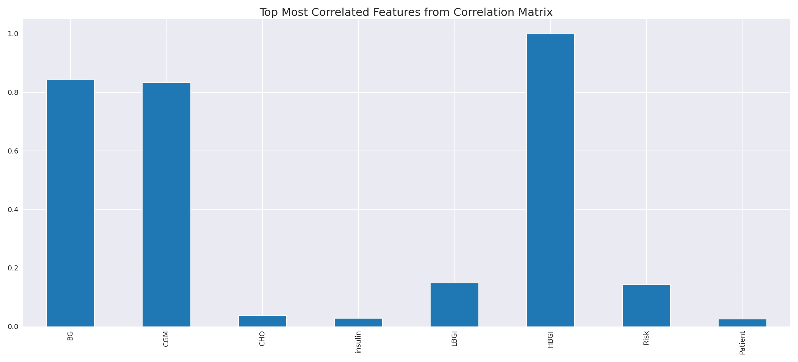

The image displays a long, blue line that represents the top most correlated features from a correlation matrix. This line is a visual representation of the strongest relationships between variables in the dataset. The line's length and position on the graph can provide insights into the interdependence of these features.  
  
The strongest correlations indicate that the variables are highly related, and understanding these relationships can help in identifying the key features that contribute to the overall performance or outcome of the dataset. This information can be valuable for data analysis, modeling, and decision-making processes.  
  
In summary, the image presents a visual representation of the most correlated features from a correlation matrix, highlighting the strongest relationships between variables in the dataset. This information can be useful for understanding the interdependence of these features and making informed decisions based on the dataset's characteristics.

Missing Numbers Graph Analysis

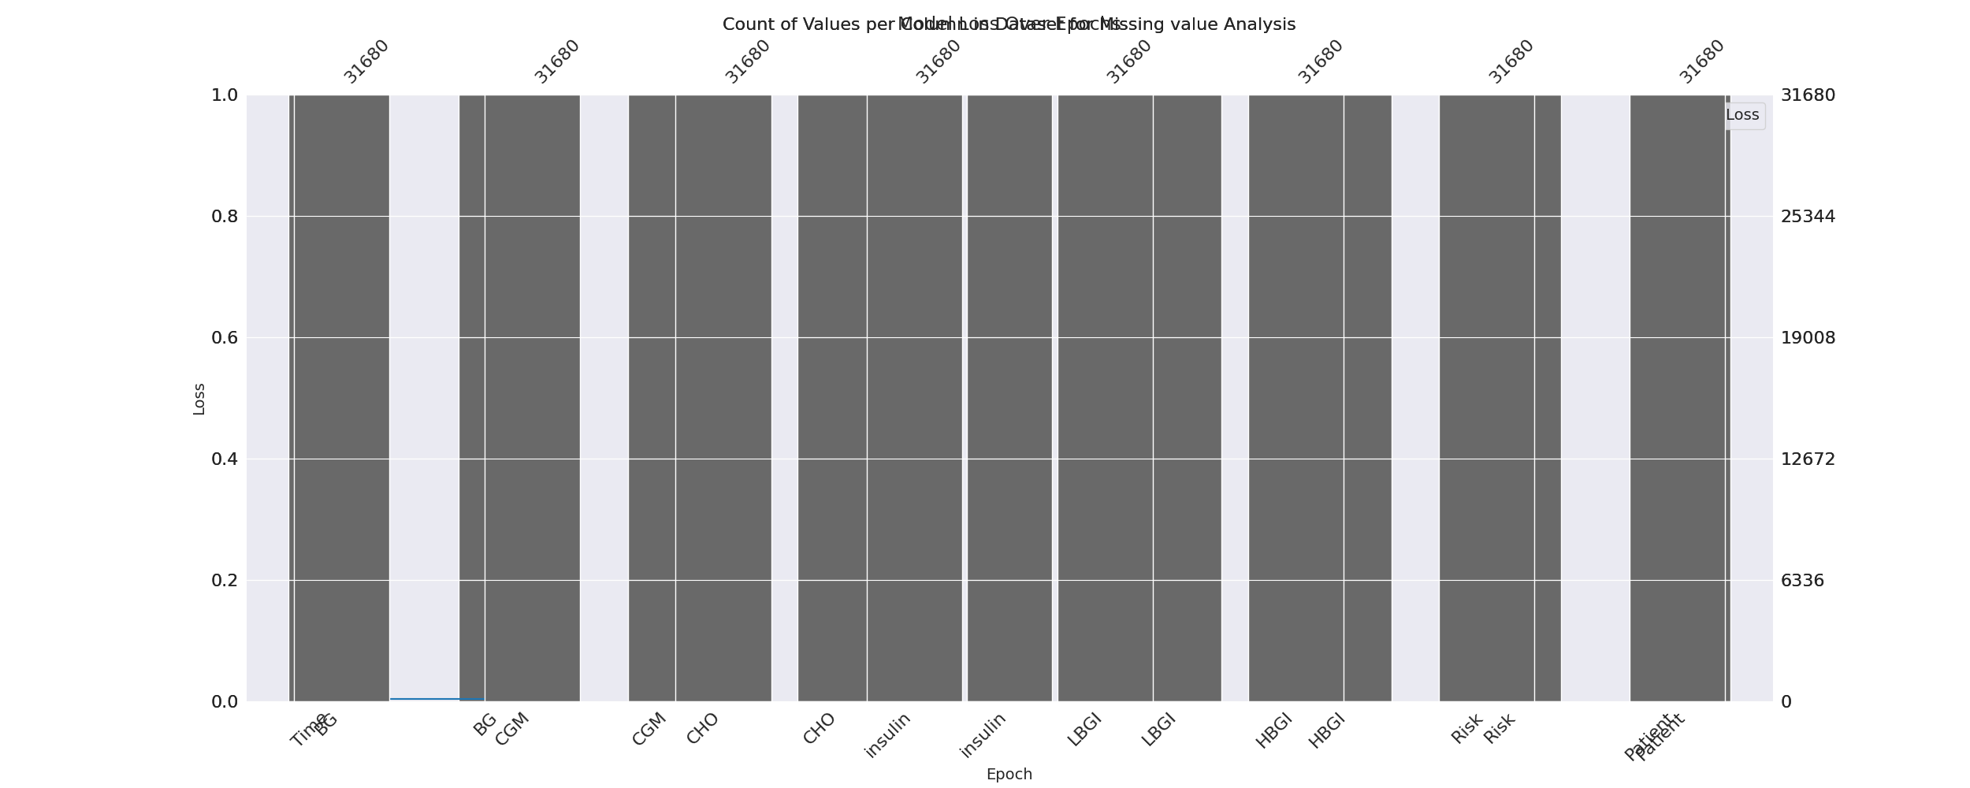

The image displays a graph with a series of numbers, including values and missing values. The numbers are arranged in a line, and the missing values are represented by a blank space. The graph is labeled with the names of the missing values, such as "missing value analysis."  
  
The presence of missing values in the data can impact data analysis or modeling in several ways. It may lead to biased or inaccurate conclusions, as the missing values could be indicative of certain trends or patterns that are not being captured. To address this issue, exploratory data analysis (EDA) techniques can be employed to identify missing values and understand their impact on the data.  
  
EDA techniques involve visualizing the data, looking for patterns, and identifying outliers. By examining the distribution of the data, one can identify the missing values and assess their impact on the overall analysis. For instance, if the missing values are concentrated in a specific region or demographic, it may be necessary to adjust the analysis to account for this bias.  
  
In conclusion, the image highlights the importance of addressing missing values in data analysis and modeling. By employing EDAs, one can better understand the impact of missing values and adjust the analysis accordingly.

Heat_Explainer Graph Analysis

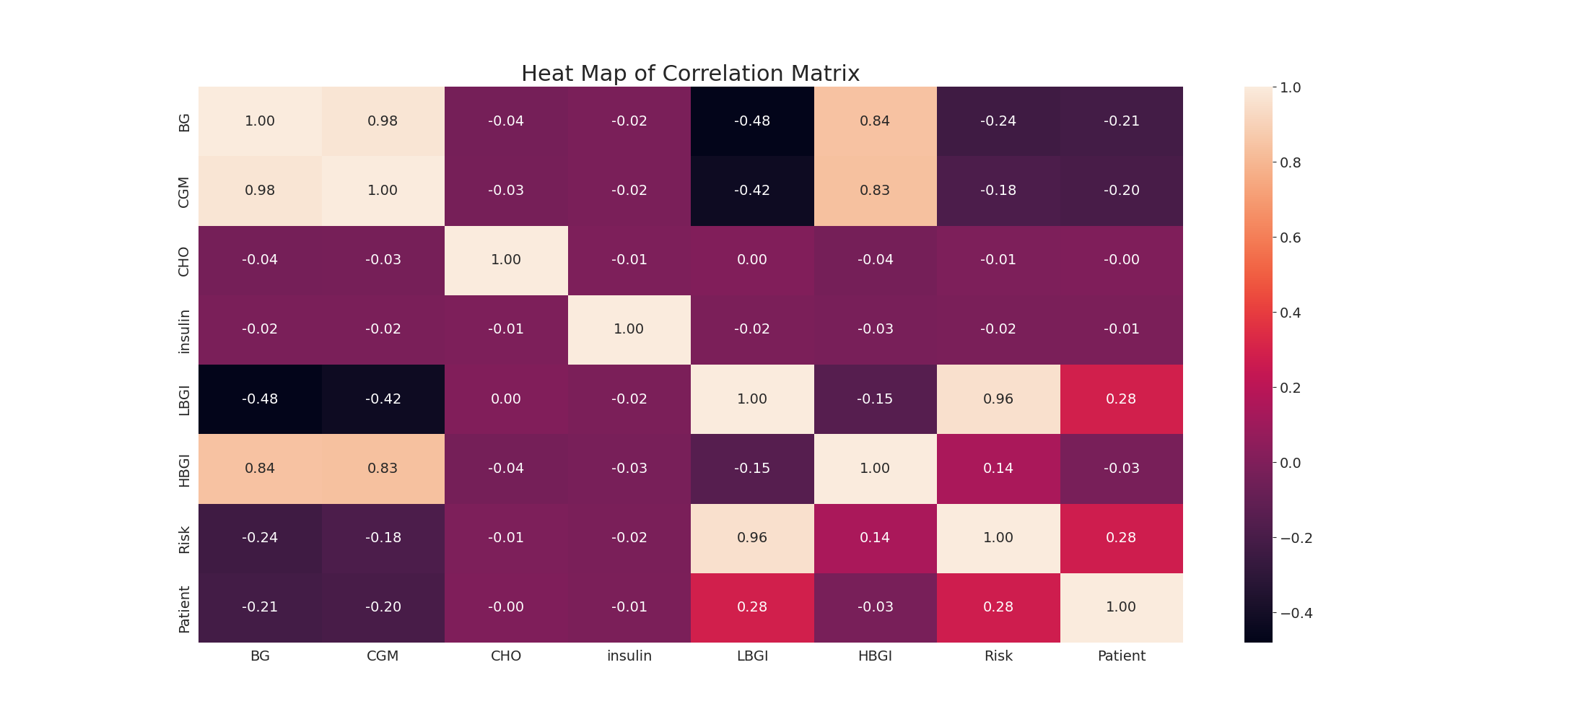

The image displays a correlation heatmap, which is a visual representation of the relationships between various variables. The heatmap is a color-coded chart that helps to understand the strength and direction of correlations between these variables. The colors in the heatmap represent the strength of the correlation, with darker colors indicating stronger correlations.  
  
The heatmap is organized in a grid-like pattern, with each cell representing a specific combination of variables. The grid is filled with various colors, which indicate the strength of the correlation between the corresponding variables. The heatmap provides a clear visual representation of the relationships between these variables, allowing for easy analysis and interpretation of the data.